**Justification of Title**

**Library Management system**

Library Management System we provide is developed as a reasource planning system for any type of library.

It’s basically made to track records of books owned, issued, lost, fine to be collected etc.

It’s a web based system which will help you manage everything associated with a library in a more effecient way.

A Library Management System is a project that manages and stores books information electronically according to students needs.

The system helps both students and library manager to keep a constant track of all the books available in the library.

It allows both the admin and the student to search for the desired book. It becomes necessary for colleges to keep a continuous

check on the books issued and returned and even calculate fine.

**Preface**

We Would like to say that the Projects are very essenting part of our education quota.

We are Pleased to present this project report **on M.Sc.(IT & CA) 1st Semester** At **HARIVANDANA COLLEGE .** it is quite easy to operate for end user. Your feedback is very important to improve our project knowledge.

Once you login to our website you can see all the book by our **Library Management System**.

This report contains overview of the whole project. Anyone who is technical person can understand the contact of the system is shown with figures and screens readers can find it easy to understand.

Project report is interesting experience for us. we say it is difficult from particular aspects we come to know about me theoretical ideas of the matter.

By preparing this report we have understand the need of particular training in the education field it is easier to work with **computerized system.**

**Acknowledgement**

we take great pleasure in presenting this project done in the 1st semester of M.Sc(IT&CA).we would like to mention here that this project would not have been possible without the invaluable support and guidance of our professors.

As the final frontier toward achieving a M.Sc(IT&CA) the activity of going through IT project has bridge the gap between the academic and practical real life work for us. It has prepared us to apply ourselves to become good IT professional.

On the even of completion of our project regarding **Library Management System.** We would like to express our gratitude to the following individuals.

We are extremely grateful to them who were helped us. we would like to give our special thanks to **Mr. Bhavesh Chavda** for stimulating discussion & Suggestions.

It has been rich and rewarding experience studying at Harivandana College of M.Sc.(IT&CA)

**Project profile:**

Project Title : “Library Management System”

Hardware Used : 4.00GB RAM ,64-bitoperating system

Operating System : Windows-10

Front End : Laravel

Back End : My SQL

Documentation Tools : Microsoft Word

Project Guide : Mr. Bhavesh Chavda

Project Duration : 3 Months

Prepared By : Disha Surani

Submitted To. : Saurashtra University,Rajkot.

***Technology study***

* ***About frontend***
* **HTML:-**

HTML is computer language devised to allow Website creation. These website can then be viewed by anyone else connected to internet. It is relatively **easy to learn** with the basic being accesible to most people in one sitting and quite **powerful** in what it allow you to create. It is constantly undergoing revision and evaluation to meet demand and requirement of the growing. Internet audience under the direction of the W3c, the organisation charged with designing.

* **HTML is the standard markup language for creating web pages.**
* HTML stands for Hyper text markup language.
* **HTML describe the structure of web pages using markup.**
* HTML elements are the building blocks of HTML pages.
* **HTML elements are represented by tags**.
* HTML tags label pieces of content such as “Heading”, “Paragraph”, “Table” and so on.

# LARAVEL:-

**• What is LARAVEL?**

Laravel is a free, open-source PHP web framework.

Laravel is a server-side PHP framework

Laravel is a web application framework with expressive, elegant syntax.

Laravel is free to download and use.

**• What is Laravel file?**

**Laravel** is primarily **used for** building custom web apps using PHP.

we might some time require to get file extension from location of file or image in laravel 6, laravel 7 and laravel 8.

You can simply use pathinfo() for get file extension from string in php laravel.

**• What can Laravel do?**

**Laravel** attempts to take the pain out of development by easing common tasks used in the majority of web projects, such as authentication, routing, sessions, and caching.

**Laravel** aims to make the development process a pleasing one for the developer without sacrificing application functionality.

Laravel can be used to control user-access.

Laravel can send and receive cookies.

**• Why Laravel?**

**Laravel** attempts to take the pain out of development by easing common tasks **used** in the majority of web projects, such as authentication, routing, sessions, and caching.

**Laravel** aims to make the development process a pleasing one for the developer without sacrificing application functionality.

**• Laravel is an amazing and popular langauge!**

PHP is one of the oldest and most popular web development languages, and Laravel is its most popular framework.

This framework gained more popularity after the release of version 3, which included features like Command Line Interface called Artisan, Support for the Database system and migrations.

* **JAVASCRIPT:-**

Java script file is used mainly to run client side Java script code on webpage and its extension is .js.

The .js file contains all the HTML HEAD and BODY objects in the tags of on HTML page.

Java script is used in web Development to do such things are:-

• automatically change a formatted date.

• cause a linked-to-page to pop up in a new Window.

• cause text or image to change during a Mouse rollover.

Despite the name Javascript is essentially underlated to java programming. Through both have the common(syntax and javascript)copies many java names and naming conventions.

The language was renamed from Live Script in co-marketing deal between netscape and sun in exchange for netscape bundling sun’s java runtime with their browser.

The key design principles within javascripts are inherited from the self programming language.

* ***About Backend:-***

**• MYSQL :-**

**What is Database?**

Database is separate application that store collection of data.

Each database has one or more distinct APIs for creating, accessing, managing, searching and replicating the data it holds.

**What is RDBMS?**

We use Relational database management Systems (**RDBMS**) to store and manage huge volume of data.

This is called relation because all the data is stored into different tables and relations are established using primary key.

**MYSQL Database:-**

MYSQL is fast, easy to use RDBMS being used for many small and big business. MYSQL is developed, market and supported by MYSQL becoming so popular because of many good reasons:-

It is released under on open source license. So you have nothing to pay to use it.

It is very powerful program in its own right. it handles a large subset of the functionality of the most expensive database package.

It uses standard form of the well-known SQL data language.

It works on many operating system and with many languages including PHP, PERL, C, C++, JAVA etc………

It work quickly and work well even with large data sets.

It supports large database, up to so million rows or more in table.

The default file size limit for table is 4GB but you can increase this (**is your operating system can handle it**) to a theoretical limit of 8 million Terabytes(**TB**).

It is customizable. The open source GPL license allows programmers to modify the MYSQL software to fit their own specific environments.

It is very friendly to Laravel ,the most appreciated language for web developments.



MYSQL, the most popular open source **SQL** database management system is developed, distributed and supported by **MYSQL AB**.

MYSQL AB is commercial company, founded by the **MYSQL** developers.

**TIME LINE CHART**

|  |  |  |  |  |
| --- | --- | --- | --- | --- |
| **TASK**  **NO.** | **TASK NAME** | **START DATE** | **END DATE** | **DURATION** |
| 1 | Preliminary Investigation | 20-6-19 | 14-7-19 | 25 days |
| 2 | System Analysis | 15-7-19 | 30-7-19 | 16 days |
| 3 | System Design | 31-7-19 | 14-8-19 | 15 days |
| 4 | System Development | 15-8-19 | 1-9-19 | 18 days |
| 5 | Testing | 2-9-19 | 6-9-19 | 5 days |
| 6 | Improvement | 7-9-19 | 12-9-19 | 6 days |
| 7 | Final Testing | 13-9-19 | 18-9-19 | 6 days |

**SDLC Stagewise Implementation**

**1. Preliminary Investigation:-**

Information Gathering:

For getting Information of Library Management System We can use Google Web Site. Also we have gathered extra Information by Our College Library and our guide Mr. Bhavesh Chavda.

Requirement Analysis:

Requirement Analysis is critical to the success or failure of system or software project. For this we need to different physibility study.

Physibility Study:-

**(1).Technical Physibility :**

This Page Gives Technical Information About used hardware and software and software in our project.

**1 Editor** : Notepad

**2 Browser :** Internetexplorer

**3** **Server** : Apache

**4 Backend :** mysql

**5 Frontend :** Laravel

**6 RAM :** 4GB(3.87 GB usable)

**7 Hard disk : 6**4-bit operating system x64-Based processor

**8 Processor :** Intel(r)core(tm) i3 7020u CPU @2.30 GHZ

**9 Screen :** 17Inches

**10 Devices :** Keyboard , Mouse

**(2).Economical Physibility :**

This phase gives economical information about used Hardware and Software in our Project.

1.Software use :Microsoft Academic Alliance camous license

- All Microsoft Product

2. Software Price :11,000 rs/-

3. Hardware Price :25,000 rs/-

4. Operating System : Windows 10 enterprise ( 64 bits)

**(3).Operational Physibility :**

Who needs Books issue or return can use our site for get Information about Book.

Our Project can used for both beginners and Advance Users.

**Request Approval:-**

Analysis approved the demands of user and ready to develop the project.

We can gone though the Investigation process and Ready/agree to develop this poject.

**2. System Analysis:-**

**\* Manual System**

In Manual system we need to explain the Library Managemenr System of Information.

We need remember the any Information about the Library Management.

Student here to Visit Library sometimes some Book are not available so Student cannot get Cetisfaction .

**\* Proposed System**

In proposed System any Student visit to our web site.

Reduace the workload of employee.

All details will be available on a click.

**3. System Design**

**Data Dictionary**

Data Dictonary is set of information desecribing the contents,format and structure of database and the relationship between its elements, used to control access to and manipulation of the database.

Designer selects file structure and storage devices.

**Admin :-**

|  |  |  |
| --- | --- | --- |
| **Field name** | **Data Type** | **Size** |
| Admin name | Varchar | 50 |
| Password | Varchar | 100 |

1. **tbl_m_Product:-**

|  |  |  |
| --- | --- | --- |
| **Field name** | **Data Type** | **Size** |
| P_id | Int | 25 |
| P_nm | Varchar | 200 |
| P_img | Varchar | 200 |

**tbl_s_product:-**

|  |  |  |
| --- | --- | --- |
| **Field name** | **Data type** | **Size** |
| S_id | Int | 25 |
| P_id | Int | 30 |
| S_nm | Varchar | 100 |
| S_img | Varchar | 125 |
| Price | Int | 56 |
| Qty | Int | 11 |
| Tot | Int | 11 |

**tbl_cart:-**

|  |  |  |
| --- | --- | --- |
| **Field name** | **Data type** | **Size** |
| I_id | Int | 56 |
| U_id | Int | 56 |
| S_id | Int | 11 |
| I_nm | Varchar | 56 |
| I_price | Int | 100 |
| I_image | Varchar | 34 |
| I_qnt | Int | 87 |

**tbl_chout:-**

|  |  |  |
| --- | --- | --- |
| **Field name** | **Data type** | **Size** |
| Id | Int(34) | 34 |
| C_fnm | Varchar | 78 |
| C_add | Varchar | 89 |
| A_city | Varchar | 45 |
| C_phone | Int | 10 |
| C_email | Varchar | 78 |
| Grand_total | Int | 78 |

**tbl_user:-**

|  |  |  |
| --- | --- | --- |
| **Field name** | **Data type** | **Size** |
| User_id | Int | 50 |
| User_name | Varchar | 50 |
| User_emailid | Varchar | 50 |
| User_password | Varchar | 50 |
| User_mobileno | Int | 50 |
| User_address | Varchar | 50 |
| User_status | Int | 50 |

**tbl_feedback:-**

|  |  |  |
| --- | --- | --- |
| **Field name** | **Data type** | **Size** |
| Fid | Int | 11 |
| Name | Varchar | 45 |
| City | Varchar | 15 |
| e-mail | Varchar | 25 |
| Message | Varchar | 90 |

**Data Flow Diagram:-**

It is Graphical representation of the “flow” of data through an information system, modeling its process aspect.

The DFD is also known as bubble chart where user processing carried out on this data, and the output data generated by the system.

The main reason DFD technique is so popular is on the account of the fact. That it is very simple formulism it is simple to use and understand.

It can be used for the visulization of data processing.

It show what kind of information will be input to and output from the system, how the data will advance through the system and where the data will be stared.

It does not show information about process timing or whether processor will operate in sequence or in parallel, unlike a traditional structured flow chart which focus on control flow, or UML activity workflow diagram, which presents both control and data flows as a unfield model.

**Following sysmbols are use in DFD:**

|  |  |  |
| --- | --- | --- |
| **Symbol** | **Name** | **description** |
|  | Arrows | The flow of data between data star external entities and process. |
|  | Circles | A process manipulate data and representation grahpical as a circle rectangle will rounded edge. |
|  | Open-ended box | Data store where data is held temporary or pernately. |
|  | Square | Exteranl entities such as people or other systems that feed data to data from the system, remove the person from the box. |

**• Step to create DFD:-**

1.Create a list of activities.

2.Construct context level DFD.

3.Context 0 level DFD.

4.Construct 1 level DFD.

5.Check again rules of DFD.

**• List Of Activities in our Project:-**

User registration

Add/Edit/Delete Category

Add/Edit/Delete SubCategory

Add/Edit/Delete about us Details

Add/Edit/Delete Feedback Details

View User-info Details

View Feedeback Details

View contact

* **CONTEXT LEVEL DFD:-**

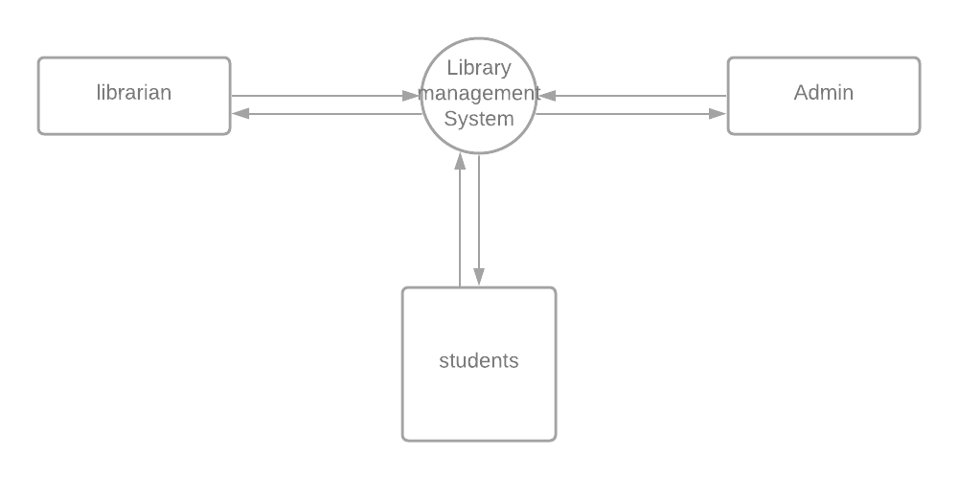

* **0 LEVELDFD:-**

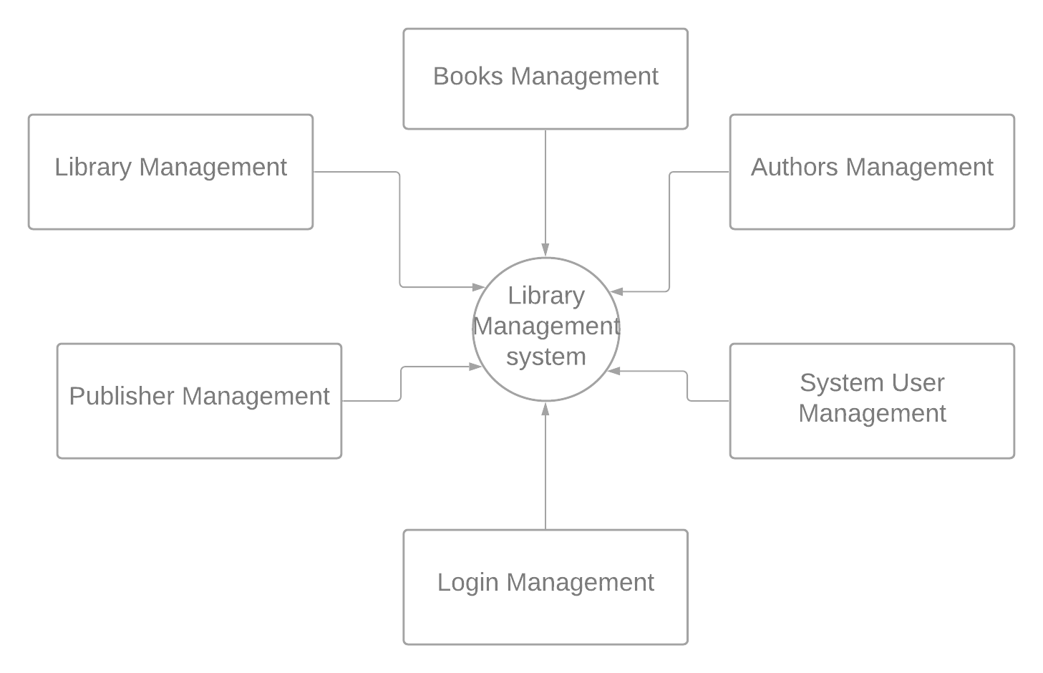

**1 LEVEL DFD:-**

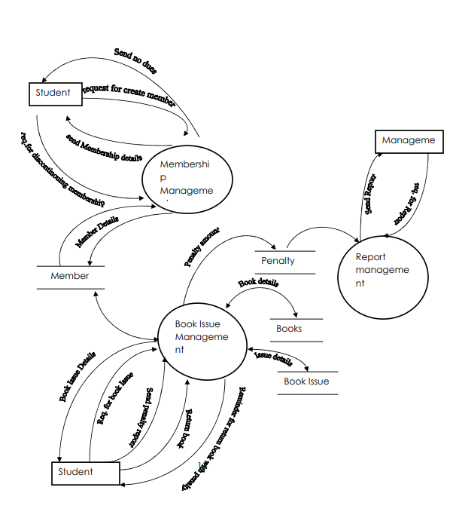

**E-R DIAGRAM:-**

e-r diagram stand for entity relation diagram. It shows the representation of entities attributes, attributes of entities, relationship sets and its attributes.

**ENTITY:-**

An entity can be any object,cart,user or bill. In e-r diagram entity can be represented using rectangle. Consider an example of entities in our project (admin,login,home,category,subcategory,feedback,contact,about).

**ATTRIBUTES:-**

Attributes describe property or characteristic of entity. In e-r diagram entity can be represented using ellipse consider example of attributes in our project(c_id,c_nm,c_img) for entity(category).

**RELATIONSHIP:-**

Relationship describes relations between entities, it can be represented by diamond shape and are connected bya line.

1. **ONE TO ONE:-**

This type of relationship means one entity is associated with one number of same entity.this type of relationship is rerely seen in real word.

1. **ONE TO MANY:-**

This type of relationship means one entity is associated with amny number of same entity.

1. **MANY TO MANY:-**

This type of relationship menas many entity is associated with many number of same entity.

**E-R DIAGRAM** is graphical method of representing entity classes, attributes and relationship.

**E-R DIAGRAM USES SIX BAISC SYMBOLS**:-

**RECTANGLE:-**

A rectangle to denote an entity set.

**DIAMOND:-**

A diamond to denote a relationship between two entity.

**OVAL:-**

An oval to denote attribute.

**LINE:-**

A line which links attributes to an entity or entity set and entity sets to relationships.

**SINGLE:-**

**1**

A ‘1’ to denotes single occurrence.

**MULTIPLE:-**

M

A ‘M’ to denote multiple occurrence.

When an E-R diagram is built .The first step is defining entities. The next step is defining the relationship between the entities. The final step to identify the attributes that belong to each entity .Once the E-R diagram is completed.

**E-R DIAGRAM:-**

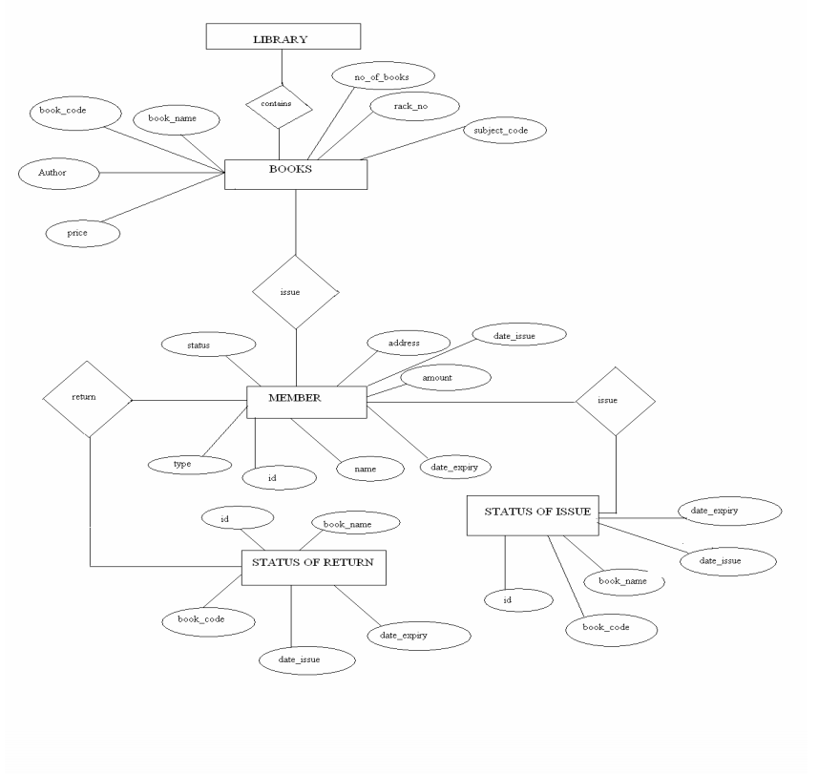

**Unnormalization:-**

An unnormalizad table is a table that does not meet the definition of relation.

It contains rows with multiple values for an attribute (repeating groups)or contains duplicate rows.

**• Categories:**

|  |  |  |
| --- | --- | --- |
| **P_id** | **p_nm** | **P_img** |
| 1 | Plates | Indexk.jfif |
| 2 | Bowl | Imagesk.jfif |
| 3 | Spoone | S2.jfif |
| 4 | Food container | Images.jfif |
| 5 | Glass | Ugtf.jfif |
| 6 | Cup | D7.jfif |

**• Subcategories:**

|  |  |  |  |  |  |  |
| --- | --- | --- | --- | --- | --- | --- |
| **S_id** | **P_id** | **S_nm** | **S_img** | **Price** | **Qty** | **Tot** |
| 1. | 2 | Bowl | Jk.jfif | 67 | 1 | 50 |
| 2. | 1 | Area leaf plates | Imaged.jfif | 90 | 1 | 50 |
| 3 | 6 | Done cup | Frgt.jfif | 20 | 1 | 50 |
| 4 | 3 | Eco friendly | S8.jfif | 35 | 1 | 50 |
| 5 | 5 | Steam were | Tgt.jfif | 60 | 1 | 50 |
| 6 | 2 | Silver paper | Image.jpg | 35 | 1 | 50 |
| 7 | 5 | Custom shot | Asst.jpg | 78 | 1 | 50 |
| 8 | 4 | Plastic food packing | Image.jfif | 89 | 1 | 50 |
| 9 | 4 | Compartment food paking | Imgt.jfif | 90 | 1 | 50 |
| 10 | 6 | Paper cup | Gedre.jfif | 67 | 1 | 50 |
| 11 | 5 | Clear plastic | Image.jfif | 89 | 1 | 50 |
| 12 | 2 | Eco friendly | Imghhjfif | 67 | 1 | 50 |
| 13 | 5 | Water glass | S3.jfif | 89 | 1 | 50 |
| 14 | 3 | Wooden | n.jfif | 56 | 1 | 50 |
| 15 | 1 | Table were set plate | Nhj.jfif | 78 | 1 | 50 |
| 16 | 3 | Generic | Ghgh.jpg | 90 | 1 | 50 |
| 17 | 4 | Food container | Sghf.jpg | 90 | 1 | 50 |
| 18 | 5 | Elegant plastic glass | Jk.jfif | 67 | 1 | 50 |
| 19 | 2 | Erica leaf bowls | Fdgd.jfif | 90 | 1 | 50 |
| 20 | 6 | Plasic cup | Tgtgt.jfif | 99 | 1 | 50 |

* **Normalization:-**

Normalization is the process of organizing the column and table or relation database to reduce data redundancy and improve data integrity.

It is also the process of simplifying the design of database so that it archives the optimal database structure.

It was first proposed by edgar F,code as an integral part of relation model.

It involves arranging attribute in relation based on dependencies between attributes ensuring that the dependencies are properly enforced by database intergrity constraints.

It is accomplished by applying some formal rules either by process of synthesis or decomposition.

The process by which we efficiently organize data to achieve three goals.

1. Eliminating redundancy.
2. Ensuring data is stored in correct table.
3. Eliminating need for restructuring database when data is added.

Edgar F,codd,the inventar or the relational mode (RM), introduced the concept of normalization.

1. **First Normal Form(1NF) :**

**.** it is proparty of relation in relational database.

**.** relation is in first normal form if and only if the domain of each attribute contains only indivisible values and the value of each attribute contains only single value from the domain.

* **First normal form enforces these criteria:-**

**.** Eliminates repeating group in individual tables.

**.** create a separate table for each set of related data.

**.** identify each set of related data with a primary key.

* **The process by which we efficiently organized data to achieve three goals;**

1. Eliminating Redundancy.
2. Ensuring data is stored in correct table .
3. Eliminating need for restructuring database when data is added.

**Categoies:-**

|  |  |  |
| --- | --- | --- |
| **P_id** | **P_nm** | **P_img** |
| 1 | Plates | Imagesk.jfif |
| 2 | Bowel | Imdexg.jfif |
| 3 | Spoone | S2.jfif |
| 4 | Food-container | Image.jfif |
| 5 | Glass | Vytf.jfif |
| 6 | Cup | d7.jfif |

**Subcategory:-**

|  |  |  |  |  |  |  |
| --- | --- | --- | --- | --- | --- | --- |
| **S_id** | **P_id** | **S_nm** | **S_img** | **Price** | **Qty** | **Tot** |
| 1 | 2 | bowl | Jk.jfif | 67 | 1 | 50 |
| 2 | 1 | Area leaf plates | Image.jfif | 90 | 1 | 50 |
| 3 | 6 | Dona cup | Frgt.jfif | 20 | 1 | 50 |
| 4 | 3 | Eco frendly | S8jfif | 35 | 1 | 50 |
| 5 | 5 | Custom shot | Tgt.jfif | 60 | 1 | 50 |
| 6 | 2 | Silver paper | Image.jpg | 35 | 1 | 50 |
| 7 | 5 | Custom shot | Dssf.jfif | 78 | 1 | 50 |
| 8 | 4 | Plastic food packing | Imgt.jpg | 89 | 1 | 50 |
| 9 | 4 | Com.food paking | S3.jfif | 90 | 1 | 50 |
| 10 | 6 | Paper cup | Nf.jfit | 67 | 1 | 50 |
| 11 | 5 | Clear plastic | Fpgd.jpg | 89 | 1 | 50 |
| 12 | 2 | Eco friendly paper bowl | Tgtgt.jfif | 67 | 1 | 50 |
| 13 | 5 | Elegent plastic paper | Ghgh.jfif | 89 | 1 | 50 |

1. **Second Normal Form (2NF):-**

* It is normal form usad in database normalization.
* Relation that is in 1nf must meet additional criteria if it is to qualify for second normal form.
* **Specially:**relation is in 2nf if it is in 1nf and no non-prime attribute is dependent on any proper subset of any candidate key of the relation.
* non-prime attribute of relation is an attribute that is not a part of any candidate key of the relation.
* put simply relation is in 2nf if it is in 1nf and every non-prime attribute of the relation is dependent overall of every candidate key.

**Categories:-**

|  |  |  |
| --- | --- | --- |
| **P_id** | **P_nm** | **P_img** |
| 1 | Plate | Images k.jfif |
| 2 | Bowl | Indexg.jfif |
| 3 | Spoone | S2.jfif |
| 4 | Food container | Images.jfif |
| 5 | Glass | Uytf.jfif |
| 6 | Cup | D7jfif |

**Subcategories:-**

|  |  |  |  |  |  |  |
| --- | --- | --- | --- | --- | --- | --- |
| **S_id** | **P_id** | **S_nm** | **S_img** | **Price** | **Qty** | **Tot** |
| 1 | 2 | Bowl | Jkjfif | 67 | 1 | 50 |
| 2 | 1 | Arealeaf plate | imagefjfif | 90 | 1 | 50 |
| 3 | 6 | Dona cup | Frgt.jfif | 20 | 1 | 50 |
| 4 | 3 | Eco friendly | S8.jpg | 35 | 1 | 50 |
| 5 | 5 | Stem wear | Tgt.jfif | 60 | 1 | 50 |
| 6 | 2 | Silver papar | Imagetk.jpg | 35 | 1 | 50 |
| 7 | 5 | Custom shot | Dstjfif | 78 | 1 | 50 |
| 8 | 4 | Plastic food paking | Imagejfif | 89 | 1 | 50 |
| 9 | 4 | Com.food paking | Images.jfif | 90 | 1 | 50 |
| 10 | 6 | Paper cup | Gedre.jfif | 67 | 1 | 50 |
| 11 | 5 | Clear plastic | Imageh.jpg | 89 | 1 | 50 |
| 12 | 2 | Eco friendly | Imageef.jpg | 67 | 1 | 50 |
| 13 | 5 | Water glass | Img.jfif | 89 | 1 | 50 |
| 14 | 3 | Wooden | S3.jfif | 56 | 1 | 50 |
| 15 | 1 | Table ware set plate | n.jfif | 78 | 1 | 50 |
| 16 | 3 | generic | Ghgh.jfif | 90 | 1 | 50 |
| 17 | 4 | Food container | Sggf.jpg | 90 | 1 | 50 |
| 18 | 5 | Elegant plastic glass | Jk.jfif | 67 | 1 | 50 |
| 19 | 2 | Erica leaf bowl | Fdgfd.jpg | 90 | 1 | 50 |
| 20 | 6 | Plastic cup | Tgtgt.jpg | 99 | 1 | 50 |

1. **Third Normal Form(3NF):-**

* Third normal form is normal form that is used in normalizing database design to reduce the duplication of data and ensure referential integrity by ensuring that 1) the entity is in second normal form and 2) all the attributes in a table are determined only by the candidate keys of that relation and not by any non-prime attributes.
* 3NF was designed to improve database processing while minimizing storage costs.
* 3NF data modeling was ideal for online transaction processing (OLTP) application with heavy order entry type of needs.

1. **Boyce – Codd Normal Form (BCNF):-**

* Boyce –codd normal form (or BCNF or 3.5 nf) is normal form used in database normalization.
* It is slightly stronger version of the third normal form (3NF).
* BCNF was developed to address certain type of anomalies not dealf with by 3nf as originally defined.

If a relational schema is in BCNF them all redundancy based on functional dependency has been removed although other types of redundancy may still exist.

* **Client Side**

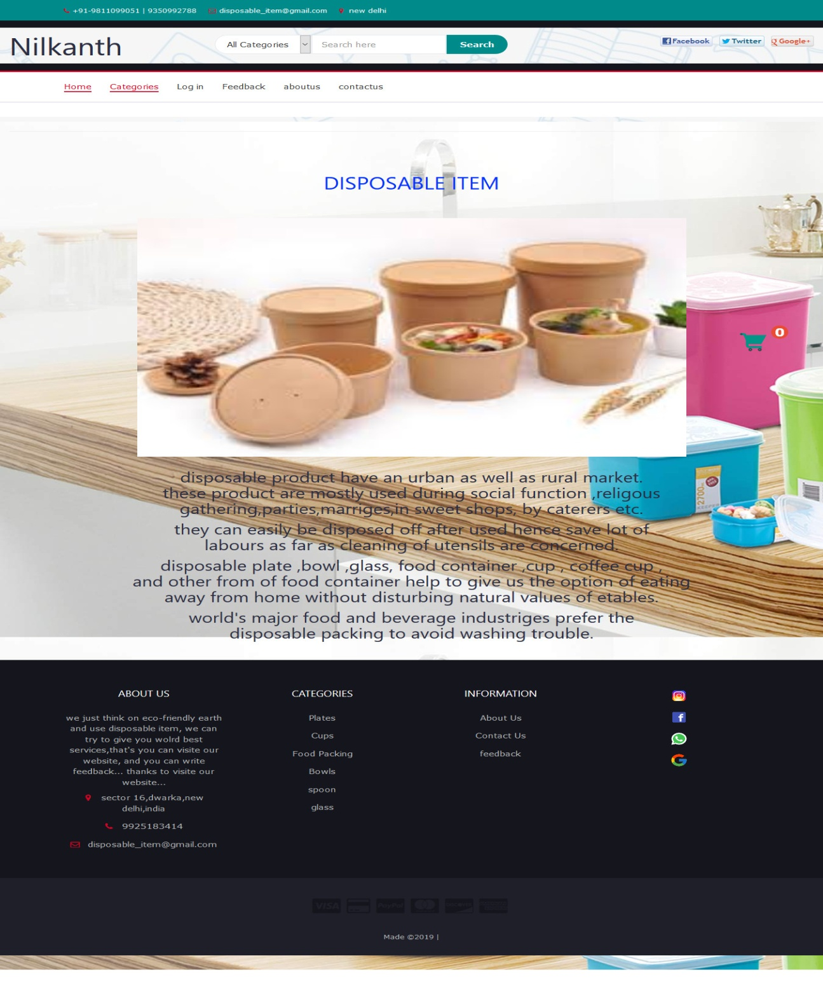

**Login**

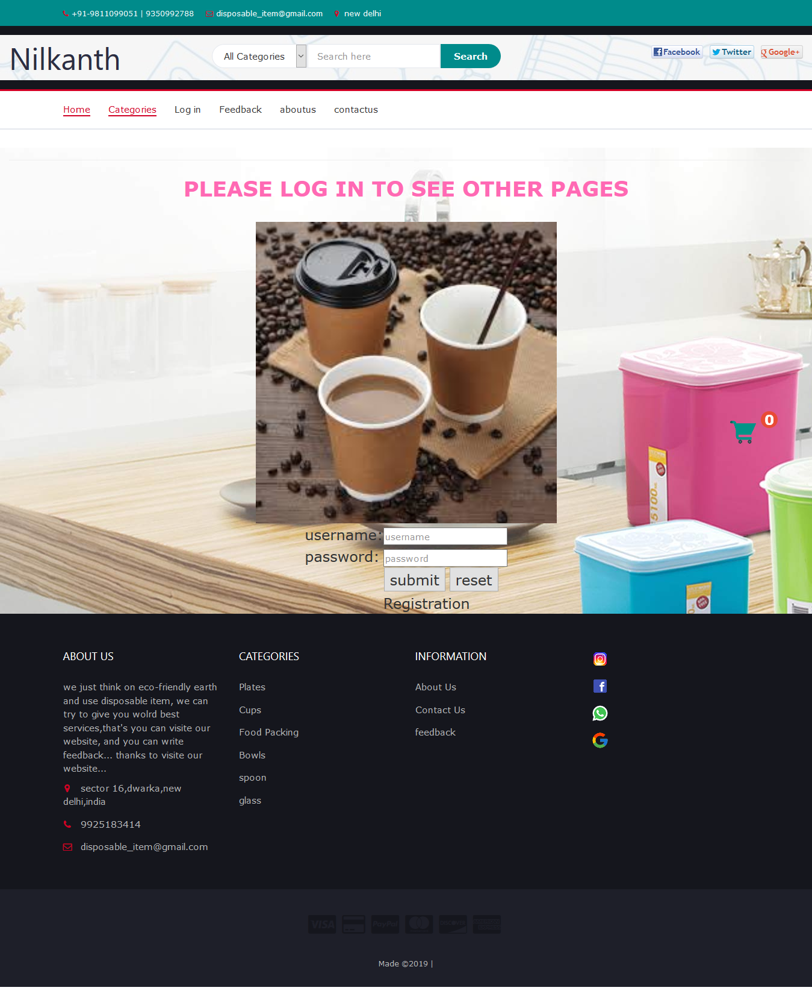

**Category**

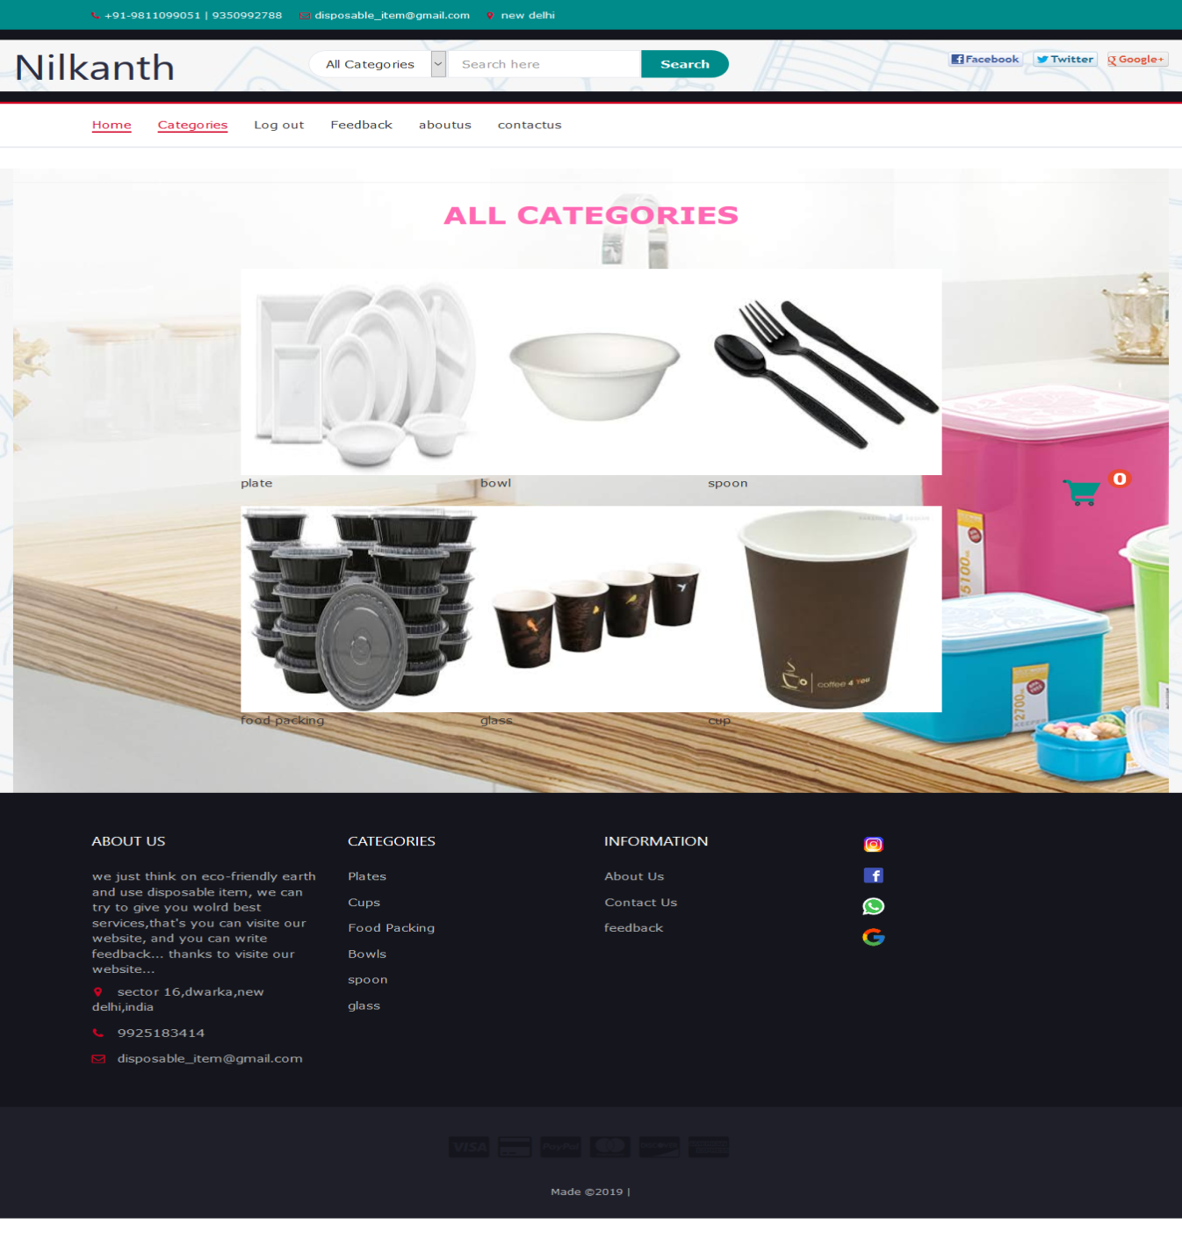

**Sub-Category**

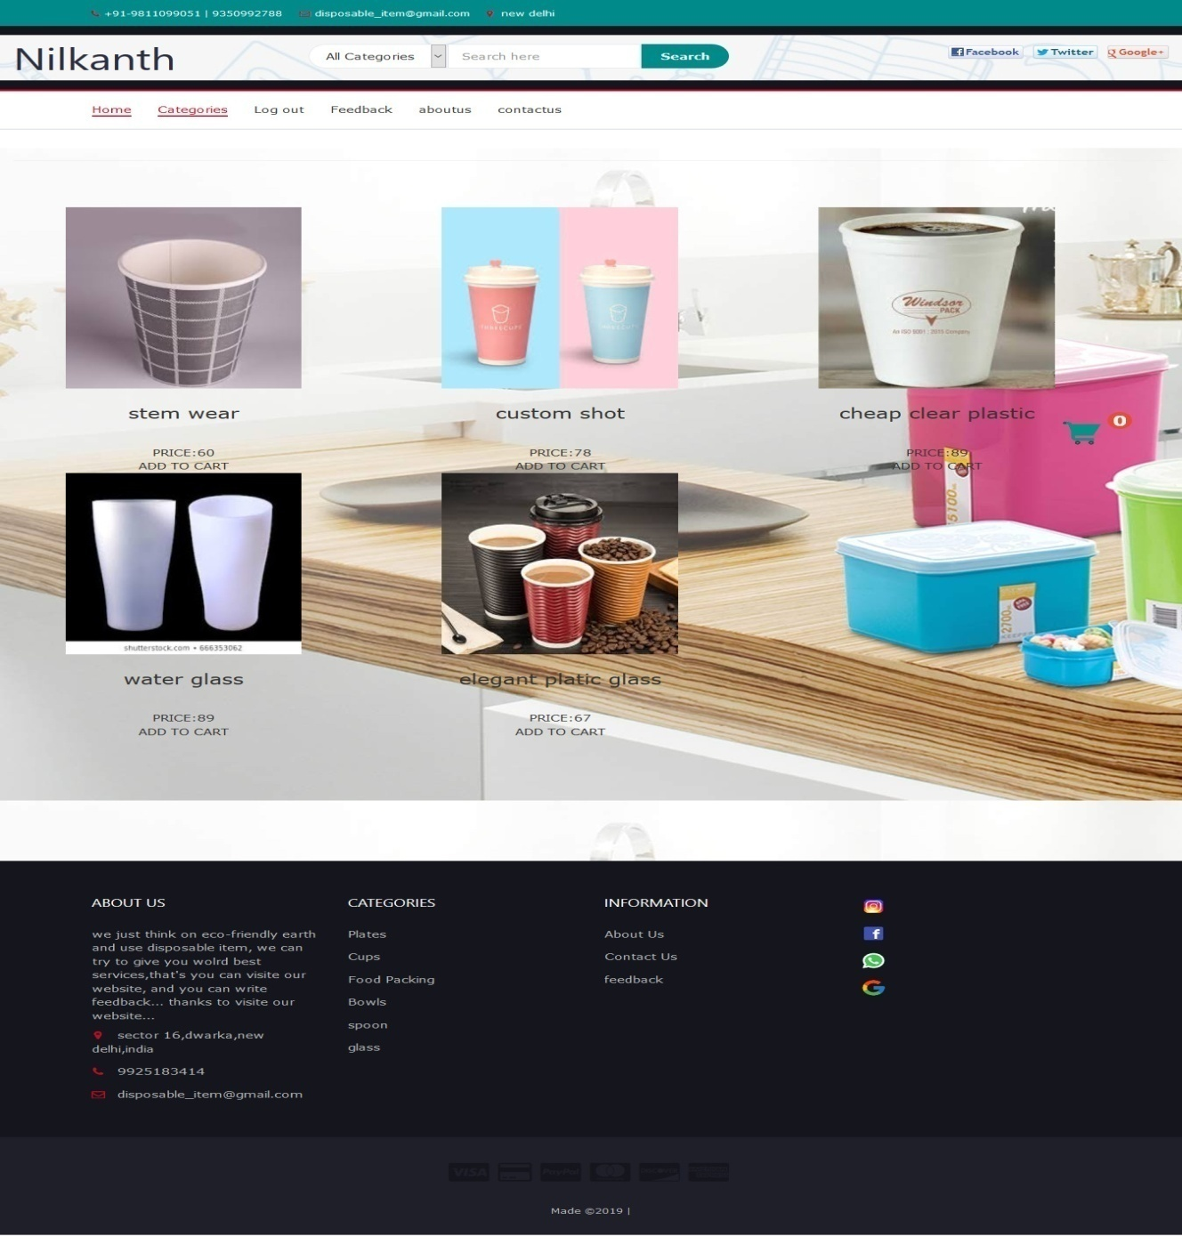

**Cart**

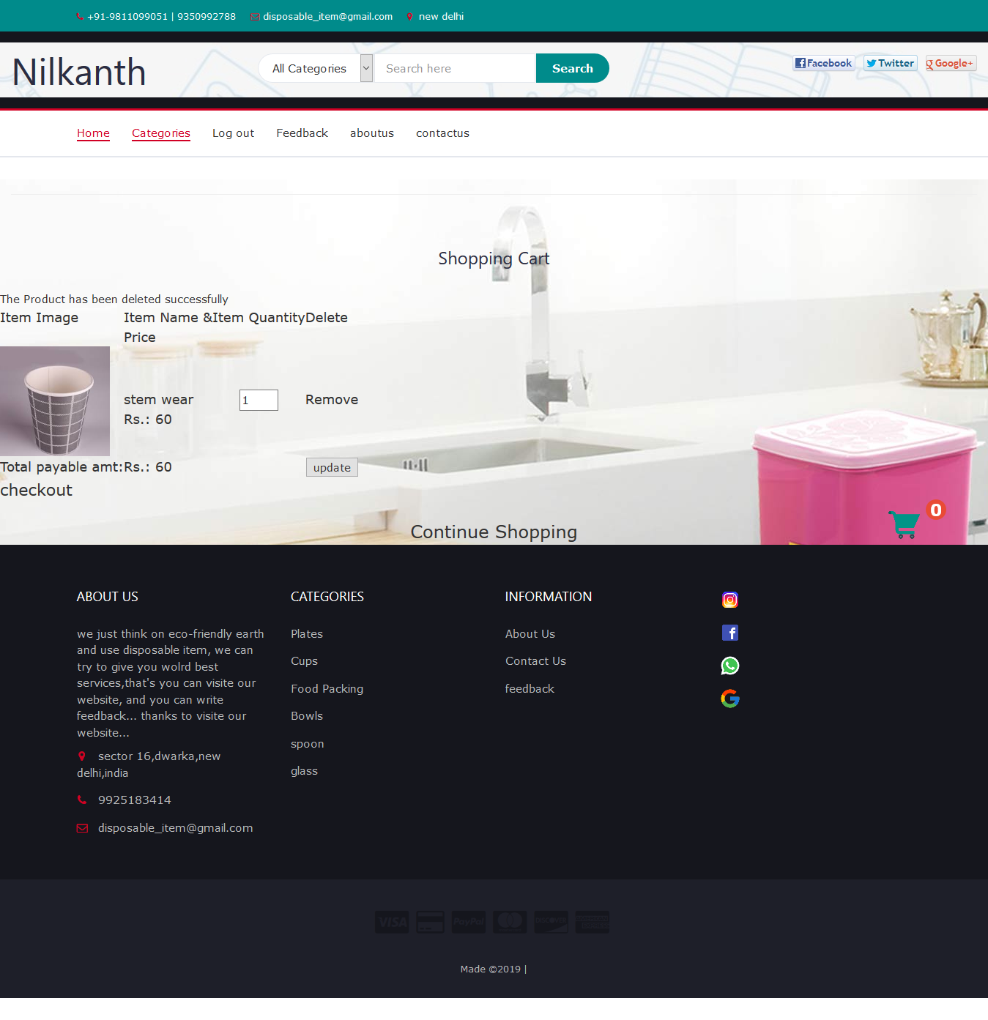

**Checkout**

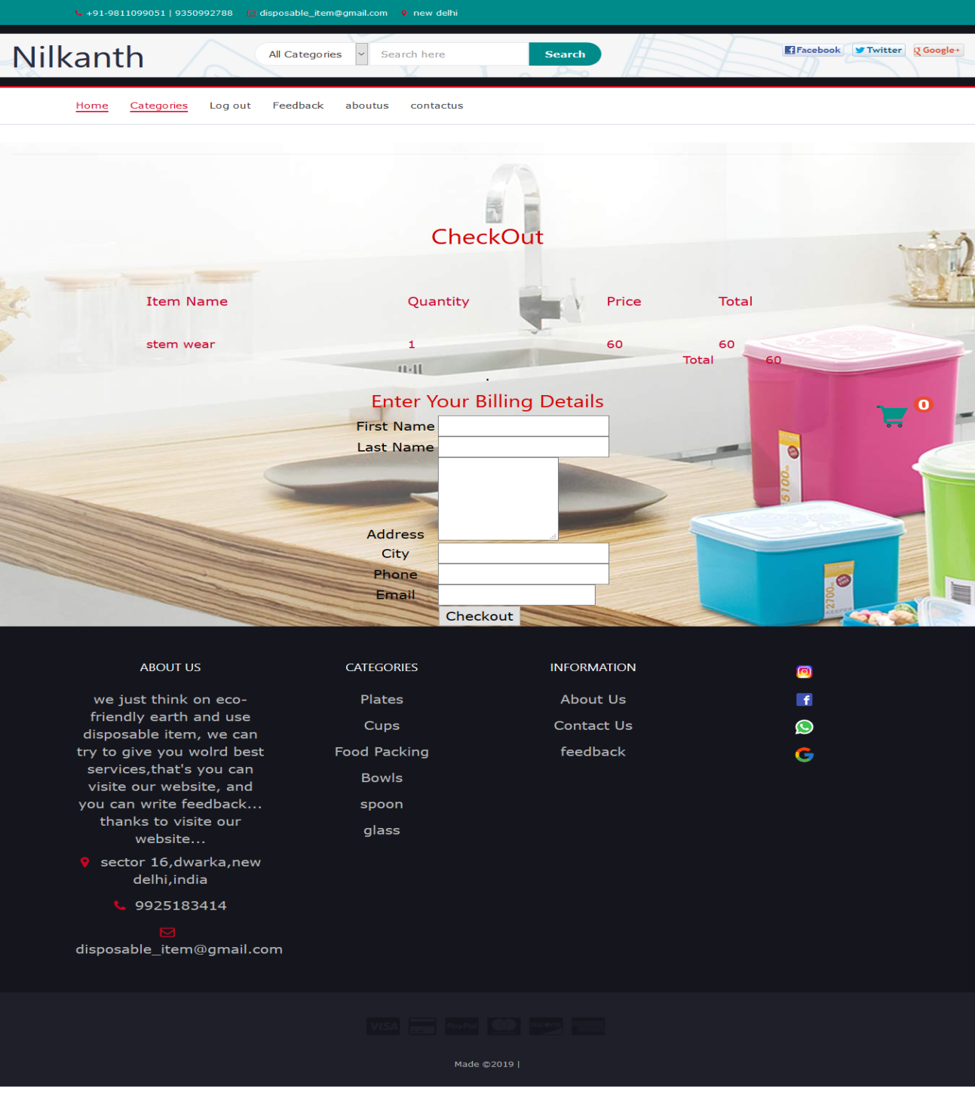

**Checkout-bill**

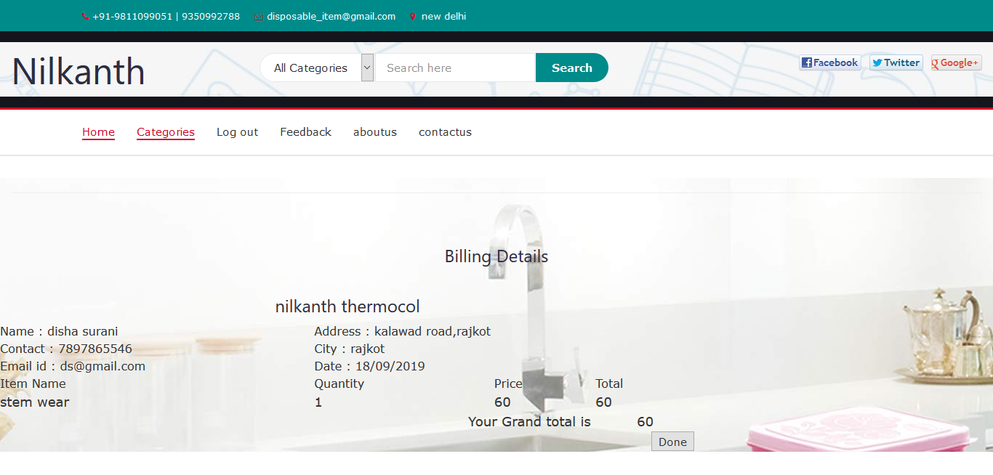

* **Admin Side**

**Home**

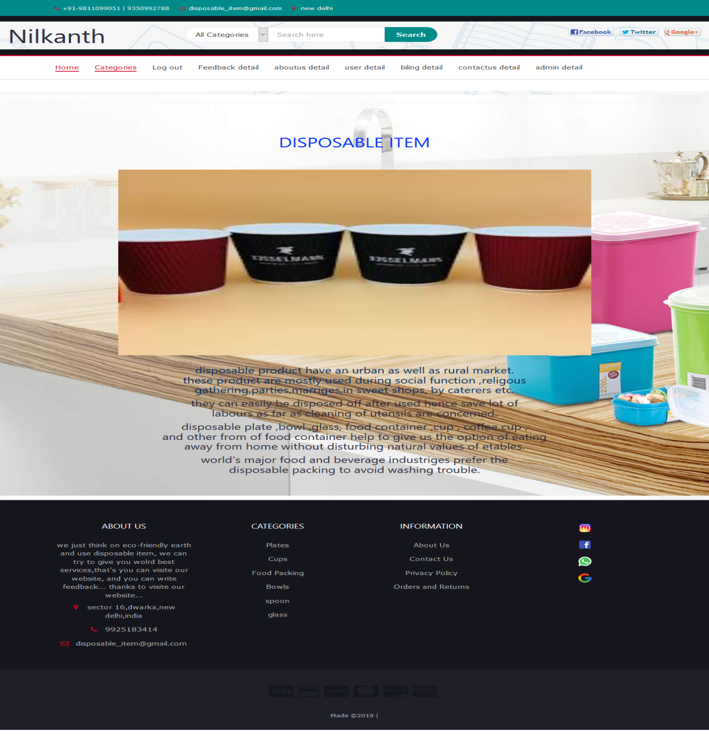

**Login**

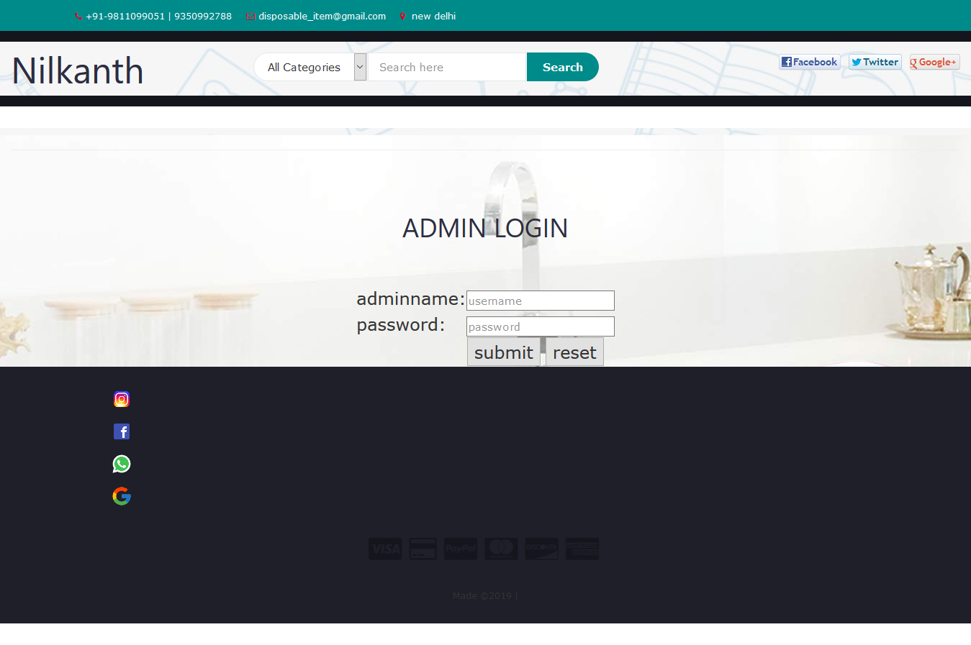

**Category**

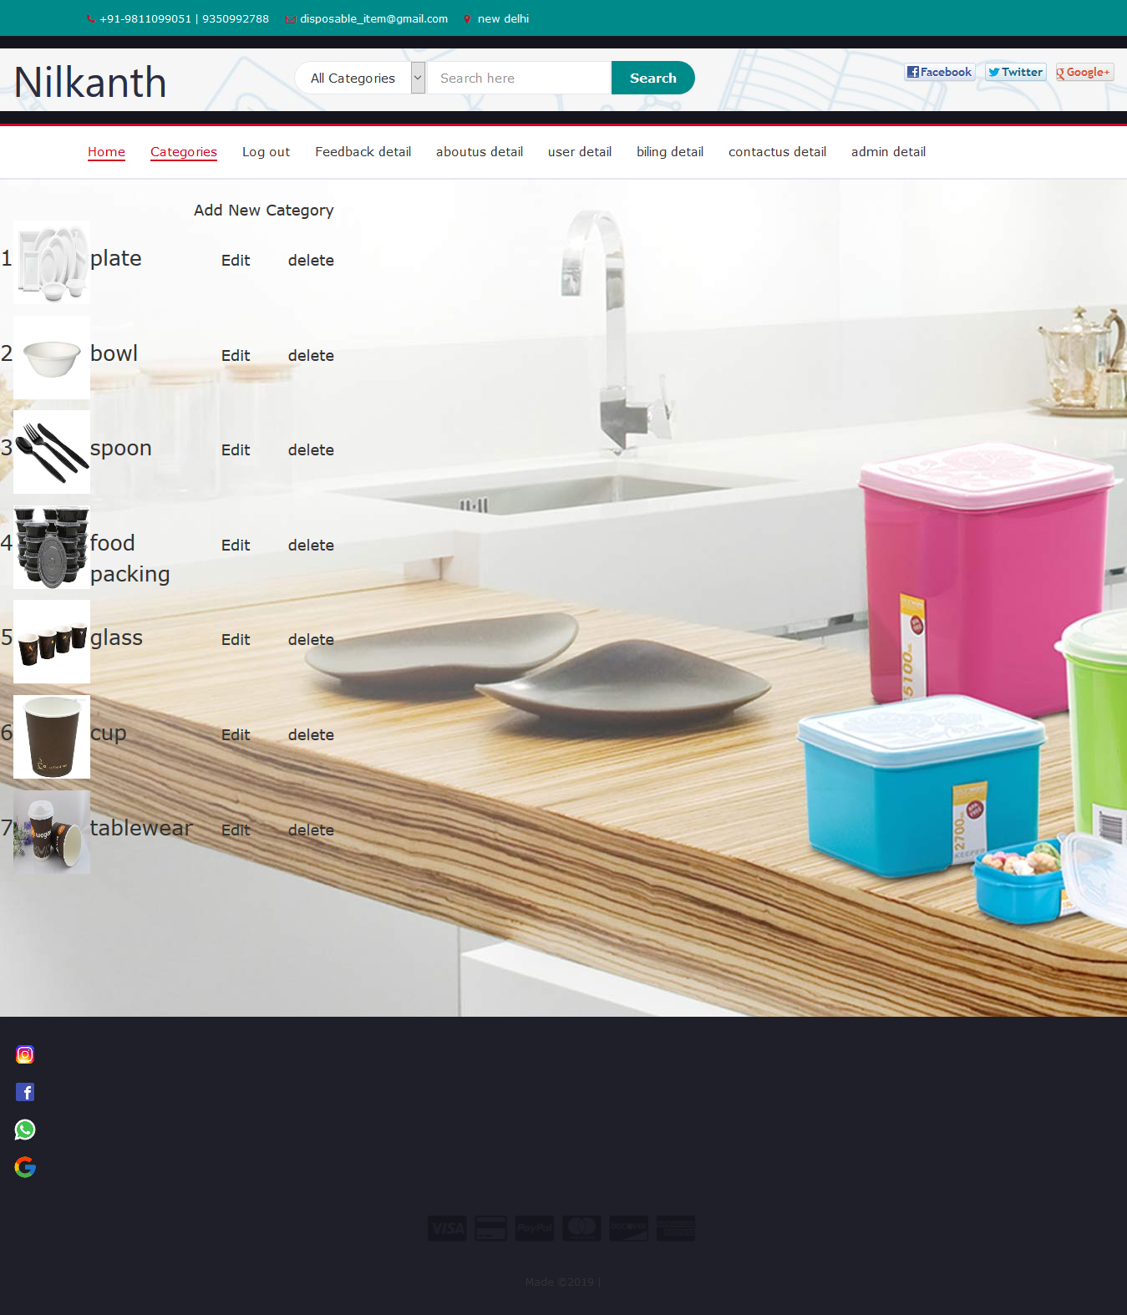

**AddCategory**

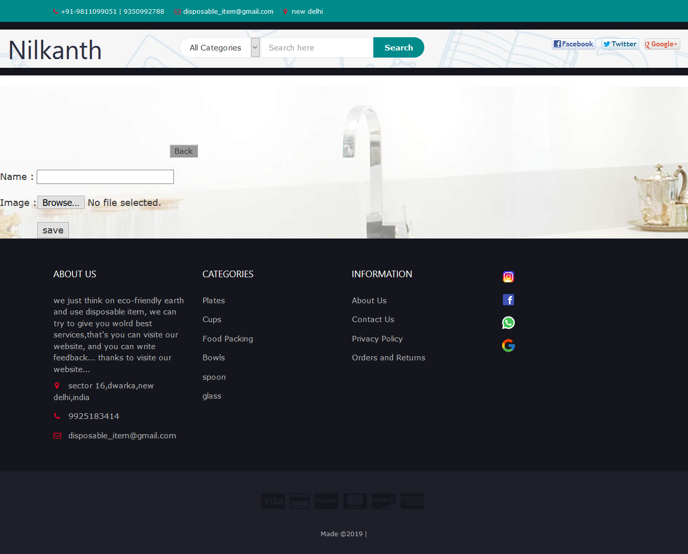

**EditCategory**

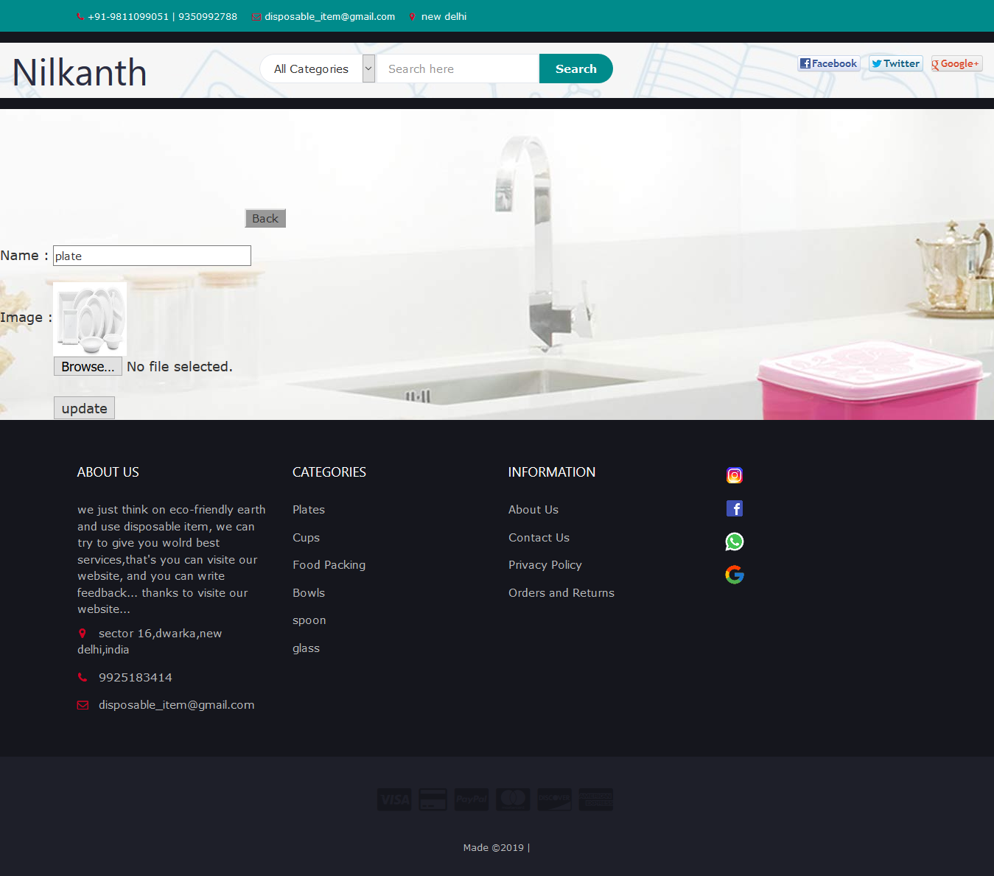

**Sub-Category**

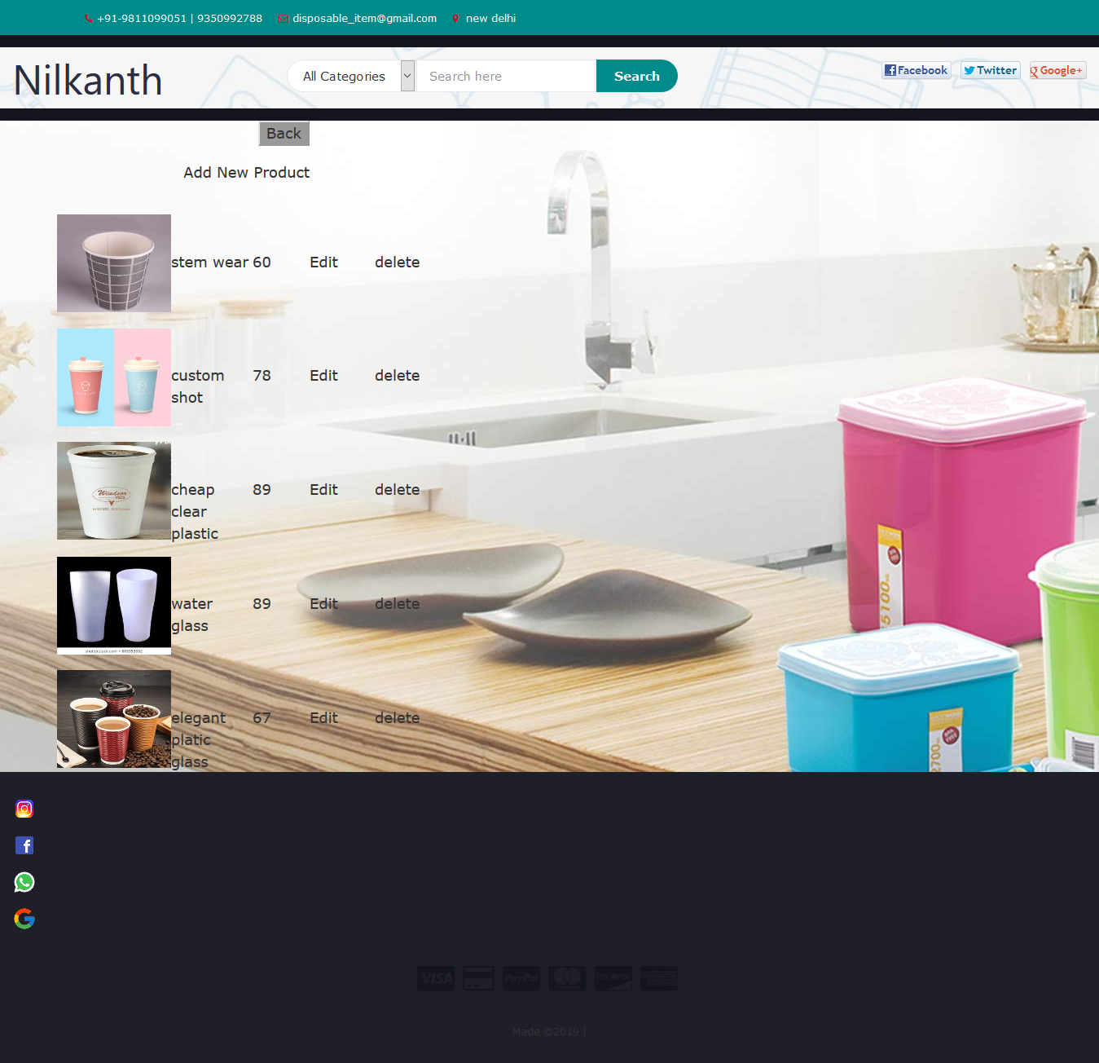

**Feedback**

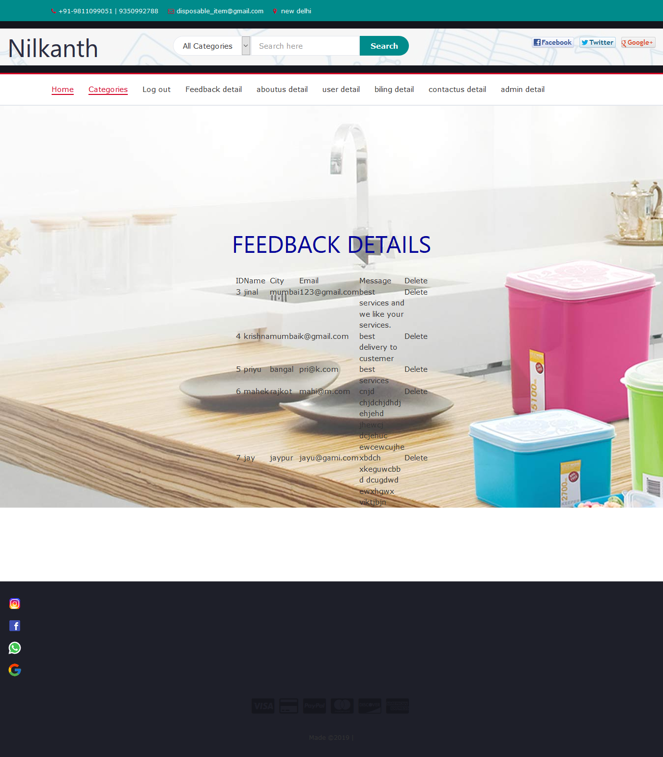

**Aboutus**

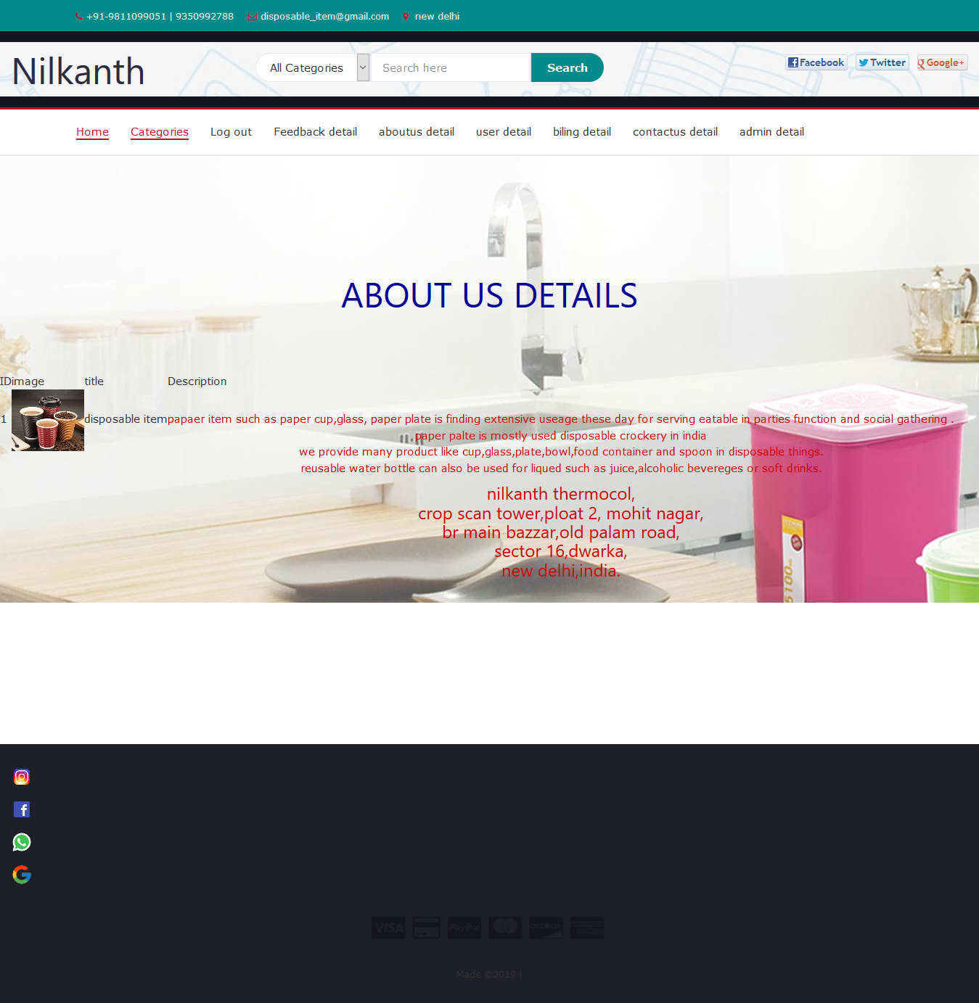

**User**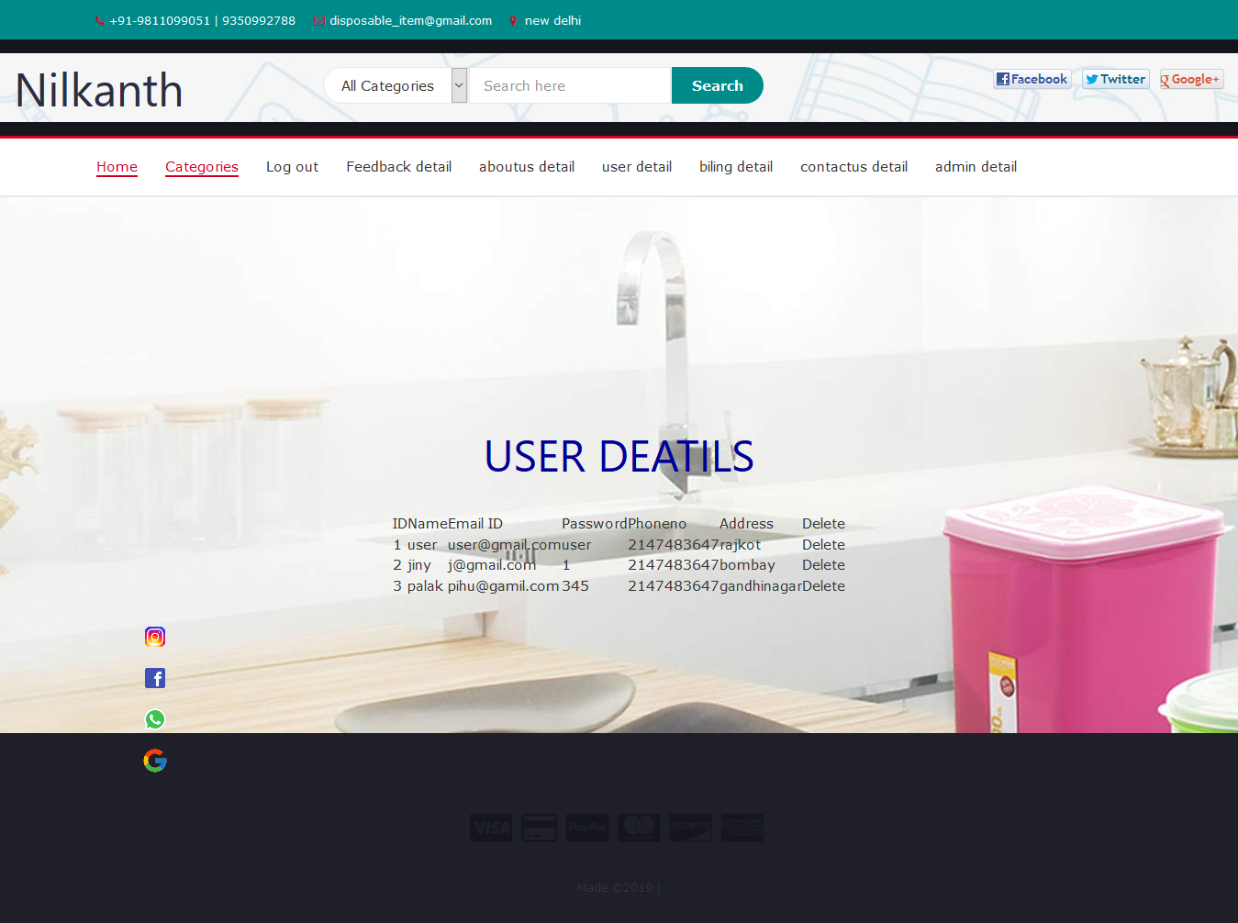

**Billing**

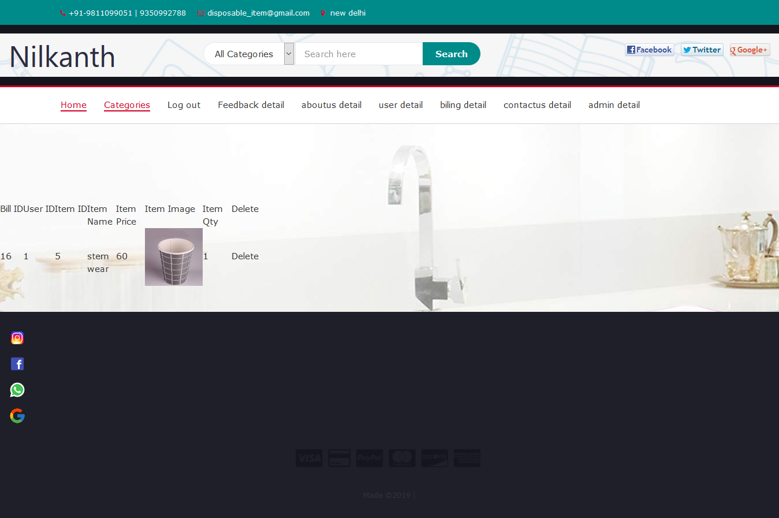

**Contactus**

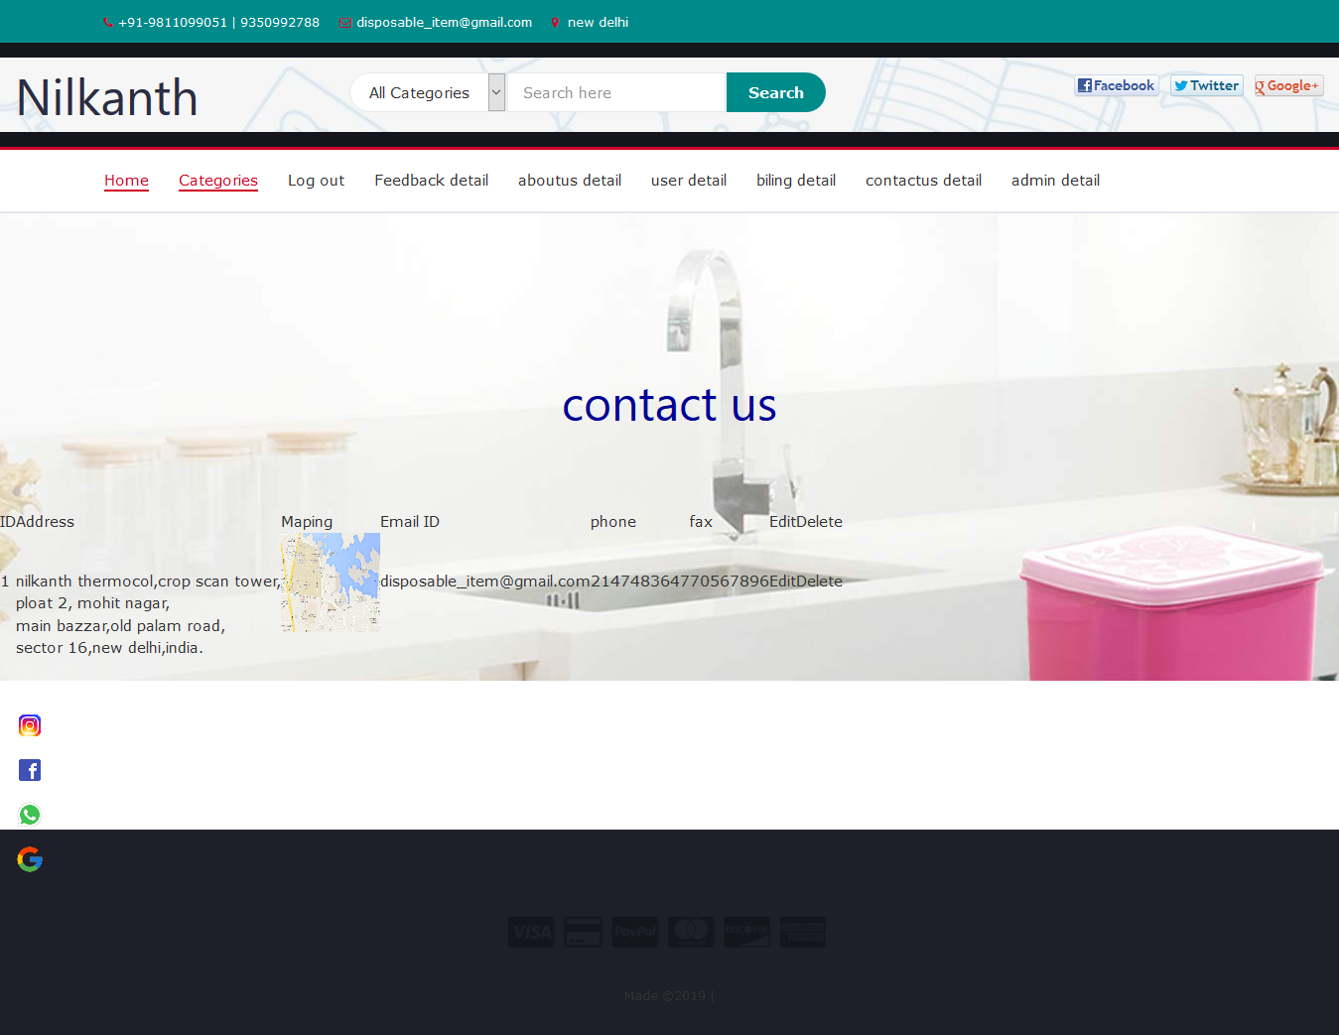

**Admindetail**

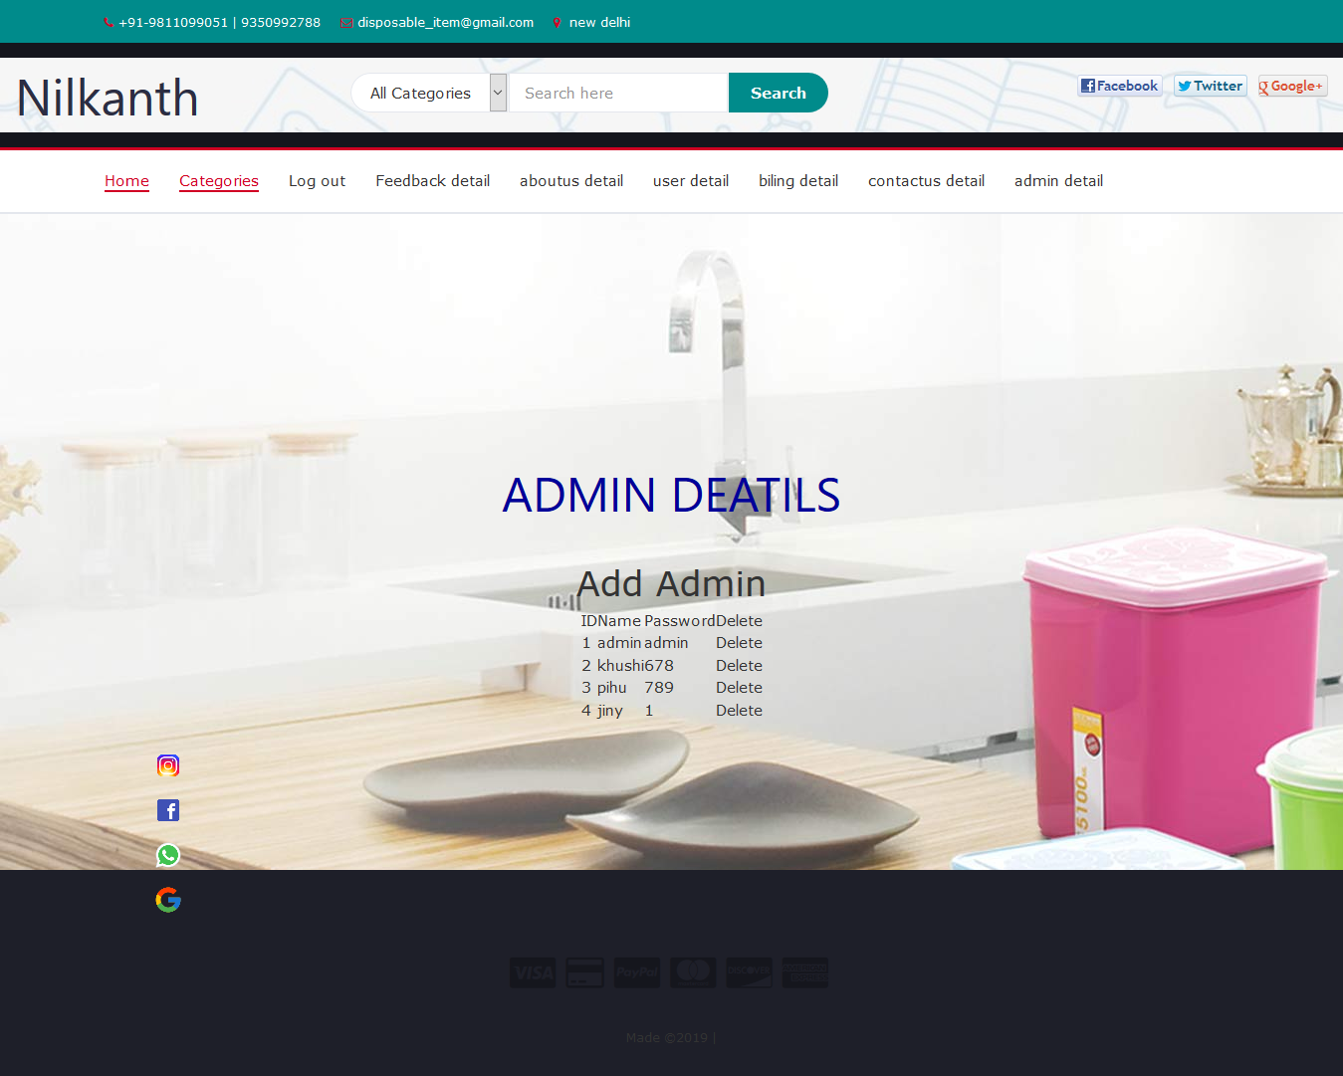

**Systerm testing**

The important and essential part of the system devlopment phase after designing and devloping the software is system testing.

We cannot say that every program system is perfect because of task of communication between the user and the designer some error is there in the software devlopment.

This a time, when all the subsystem are gathered into one pool and test whole systemto determine whather it meets the user requirment.

Testing is important function to the success of the system.

There are three techniques of software testing:-

**White box testing:**

This type of testing requires the khowldge of internal structure of software (code) which is clearly visible to programmer so it is known as white box testing.

This is also known as glass box ,structured, clear box and open box testing.

White box testing is performed by development team /programmer.

**Black box testing:**

This method is named so because the software programmer in the eyes of the tester is like a black box, inside which one cannot see.

It is also called behavioural /function testing.

It is performed by software engineer.

Tester compare real output with the expected output for success of testing process.

**Grey box testing:**

Grey box testing is combination of black box and white box testing.

It is also known as translucent testing.

**Manual testing:**

Manual testing is process which is done manually.

All the famous phases of stlc like test planning, test deployment, result analysis, test execution, bug tracking and reporting tools are obviously coming under the category of manual testing and done successfully by human efforts.

Manual testing is a start of testing, without this testing we can not start automation testing.

In manual testing we find more bugs than automation by error guessing.

It takes lot of time.

Manual testing would be run sequentially.

Regression testing process is tough in manual testing.

It is not expensive.

More testers are required in manual testing because in this testing test cases need to be executed manually.

It gives low accurancy result.

It is considered as low quality.

In this testing we cannot do batch testing.

It is considered as less reliable.

No need of programming in manual testing.

It is done without interaction of any tool.

**Automation testing:**

Automation testing is process which is done by the help of automated tools.

In automation testing all the popular phases of STLC are done by various open sources and purchased tools like selenium, I meter,QTP, load runner, win runner and so on.

Automation testing is continuous part of manual testing.

In automation testing we test the repetitive functionalities of the application.

It takes less time.

It is done on different machines at same time.

Regression testing process is easy in automation testing by tools.

It is expensive.

Few testers are required in automation testing because this testing test cases need to be executed by using automation tools.

It gives high accurancy result.

It is considered as high quality.

In this testing we can do multiple types of batch testing.

It is considered as more reliable.

Need of programming is must in automation testing.

It is always done using tools.

* **Test Case:-**

|  |  |  |  |  |  |  |  |
| --- | --- | --- | --- | --- | --- | --- | --- |
| **Test case id** | **Test scenario** | **Test steps** | | **Test data** | **Expected results** | **Actual result** | **Pass/fail** |
| Tc 01 | Check user login with valid data | 1.goto localhost://disposable/login.php  2.enter user name  3.enter password  4.click submit | | User name =user  Password=user | User can log in and redirect to index php page | As expected | pass |
| Tc 02 | Check user login with invaild data | 1.go localhost://disposable/login.php  2.enter user name  3.enter password  4.click submit | | User name=user  Password=1234 | User login and redinet to home php page | Username or password incorrect | fail |
| Tc 03 | Check user register with valid data | 1.goto localhost://disposable/registration.php  2.enter username.php  3.enter password  4.enter gender  5.confirm password  6.address  7.city  8.state  9.email id  10.phone no  11.captcha | | Username=user  Password=user  Confirm password=user address=abc city=rjk state=guj emailid [ab@email.com](mailto:ab@email.com)  Phone=9876543217 capacha | User can register and regient and redirect to login page | As expected | pass |
| Tc 04 | Check user feedback with vaild data or invaild data | 1.goto:localhost:/disposable/feedback.php  2.enter name  3.city  4.enter contect  5.enter email  6.review  7.send message | | Name=user city=rajkot  Contect=9876543217  [Email=ab@email.com](mailto:Email=ab@email.com)  Review=good serve | User should feedback and redirect to thank php page | As expected | Pass |
| Tc 05 | Check category details with vaild or invaild data | 1.goto:localhost:/disposable/category.php  2.enter user name  3.enter password  4.click submit | | User name user password=user | User can login and redinef to category php page | As expected | Pass |
| Tc 06 | Check category in cart details with valid or invalid data | 1.goto:localhost:/disposable/category.php  2.enter user name  3.enter password  4.click submit | | User name=user  Password=user | User can login and redirect to category php page | Insert query is not properly execred | Pass |
| Tc 07 | Check category in cart details with valid or invalid data | 1.goto:localhost/disposable category.php  2.enter user name  3.enter password  4.click submit | | User name=user password=user | User can login and redirect to category php page | Update query is not prperrly executed | Pass |
| Tc 08 | Check category in cart details with valid or invalid data | | 1.goto:localhost:/disposable/category.php  2.enter user name  3.enter password  4.click submit | User name=user password=user | User can login and redirect to category php page | Remove category from cart and from cart table also not executed | Pass |
| Tc 09 | Check checkout table in valid data or invalid data | | 1.goto:localhost:/disposable/checkout .php  2.enter user name  3.enter password  4.click submit | User name=user password=user | User can purchash the category and redirect to checkout php page | As expected | Pass |
| Tc 10 | Check bill table in valid data or invalid data | | 1.goto:localhost:/disposable/checkout bill.php  2.enter user name  3.enter password  4.click submit | User name=user password=user | User can purchase the category and redirect to checkout php page | Inserted in checkout table | Pass |
| Tc 11 | Check bill table in invalid data | | 1.goto:localhost/disposable/checkout_bill.php  2.enter user name  3.enter password  4.click submit | User name=user  Password=user | User should parchase category and redirect table.php | Details can not inscret in checkout table | Pass |
| Tc 12 | Check admin login with valid data | | 1.goto:localhost/disposable/admin login.php  2.enter admin page  3.enter password  4.click submit | User name=admin password=admin | Admin login and redirect home php page | As expected | Pass |
| Tc  13 | Check admin add.edit delete category with valid data | | 1.goto:localhost/disposable/admin/category.php  2.enter admin name  3.enter password  4.click submit | User name =admin  Password=admin | Admin should login and redirect to category php page | As expected | Pass |
| Tc  14 | Check admin add edit delete subcategory with valid data | | 1.goto:localhost/disposable/subcategory.php  2.enter admin name  3.enter password  4.click submit | User name =admin password=admin | Admin can login and redirect to subcategory .php | As expected | Pass |
| Tc  1  5 | Check admin add edit delete category with valid data | | 1.goto:localhost/disposable/admin/category.php  2.enter admin name  3.enter password  4.click submit | User name=admin  Password=admin | Admin and login and redirect to category php page | As expected | Pass |
| Tc  16 | Check admin add edit delete category with invalid data | | 1.goto:localhost/disposable/admin/category.php  2.enter admin name  3.enter password  4.click submit | User name=admin password=123 | Admin can login and redirect to category php page | Any query is not propare executed | Pass |
| Tc  1  7 | Check admin add.edit delete about us with validor invalid data | | 1.goto:localhost/disposable/admin/about us .php  2.enter admin name  3.enter password  4.click submit | Admin name=admin password =admin | Admin should login and redirect to about us php page | As expected | Pass |
| T  C  1  8 | Check admin add.edit delete contectus with invalid valid data | | 1.goto:localhost/disposable/admin/contect.php  2.enter admin name  3.enter password  4.click submit | Admin name=admin  Password=admin | Admin should login and redirect to contect php page | As expected | Pass |
| T  C  19 | Check admin delete feedback with invalid data | | 1.goto:localhost/disposable/admin/feedback.php  2.enter admin name  3.enter password  4.click submit | Admin name=admin  Password=admin | Admin should login and redirect to feedback php page | As expected | Pass |
| T  C  2  0 | Check user admin delete bill with valid or invalid data | | 1.goto:localhost/disposable/admin/bill.php  2.enter admin name  3.enter password  4.click submit | Admin name=admin  Password=admin | Admin can login and redirect to bill php page | As expected | Pass |
| T  C  21 | Check user logout with valid invalid data | | 1.goto:localhost/disposable/logout.php  2.enter user name  3.enter password  4.click submit | User name=user  Password=user | User can login and redirect logout php page | As expected | Pass |
| T  C22 | Check admin logout with invalid or valid data | | 1.goto:localhost/disposable/admin/logout.php  2.enter admin name  3.enter password  4.click submit | Admin name=admin  Password=admin | Admin can logout and redirect to logout php page | As expected | pass |

**Advantages & limitations of project:-**

* **Advantages:**

The main advantage is that the user can save that time compare to manual syatem.

We provide disposable item detail with photo which is conveninent for user to choose any product.

The system is configured for multiuser at this time the concept of transaction can be used to achive this.

You don’t need to wash it, so it makes things much easier if you have many guests, this also save water and electricity.

Disposable item can be reused at times in this case it might not save you the washing up time ,but it would be certainly lightweight and cheaper.

If you go for picnic with the family, your frist priority is our disposable item that you can use and throw it outside.

Disposable item’s price is lower than any other kitchenwear.

The next big advantage is the cost especially when the event is big one. It is even cheaper compared to opting for renting of crockery and cutlery items.

* **Limitations:**

Many time people use plastic item and throw outside that occasionally animals eat them and die so, it is harmful to animals.

The use of potentially dangerous chemicals,which are added as stabilizers or colorants.

Plastics generally have low melting point, so they can’t be used where heat levels are high.

Some of the plastic are recycled, most remain uncollection in dump sites and pollute the environment.

* **Future enhancement**

Our mind is always thinking new and our necessities also are growing.

That we think hot a single project is ever considered as complete forever.

As system is flexible you can generate more report and screen as and when required.

The system is modified in future as per the owner requirement.

We will add new category of disposable item in future devolepment for users.

Other social page under development for wide information.

In this system we can add more reports about users so more and more information about any items as per other future development.

We always want something morthat want we have our application also if you see at the first glance that you find it to be complete but we want to make if skill natore and fully.

**Reference and Biblography**

**\* Web sites:**

●<http://www.apachefriends.org>

●<http://www.php.net>

●<http://www.mysql.com>

**\* Search engines:**

●google search engine

●mozila firefox

●google crome

**\* References:**

●[www.google.com](http://www.google.com)

●[www.co3school.com](http://www.co3school.com)

●[www.steemit.com](http://www.steemit.com)

●[www.en.wilsipedia.com](http://www.en.wilsipedia.com)

●[www.tafaplastic.com](http://www.tafaplastic.com)

●[www.maleeircumision.org](http://www.maleeircumision.org)

**\* Books:**

●php developer

